Lab Exercise

1. Display the path of your current directory.

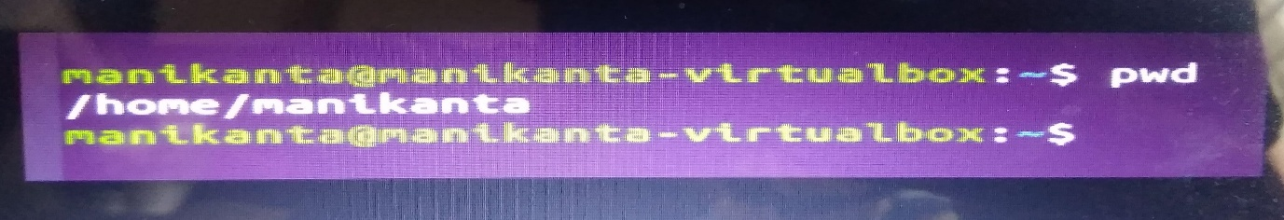 pwd

2. Make a new directory named main.

mkdir main



3. Now change to the directory main.

cd main



4. Make the directories in the following hierarchy using a single command.

Dir1  → Dir 2 →Dir3

Cd ~/dir1/dir2/dir3



5. Print the path of the current directory

.

6. Go to Dir3 using a single command.

 Cd dir3

7. Create a new file **demo1**, type and save the following contents,

This is my first file in shell.

I can edit this file!!!

Gedit demo1 and This is my first file in shell. I can edit this file!!!

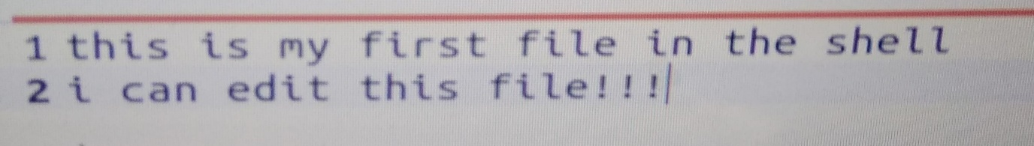

 8. Create a new file **demo2**, type and save the following contents,

Hi!!! This is the second file.

I am doing shell commands.

I can edit this file!!!

Gedit demo2 and Hi!!! This is the second file. I am doing shell commands. I can edit this file!!!

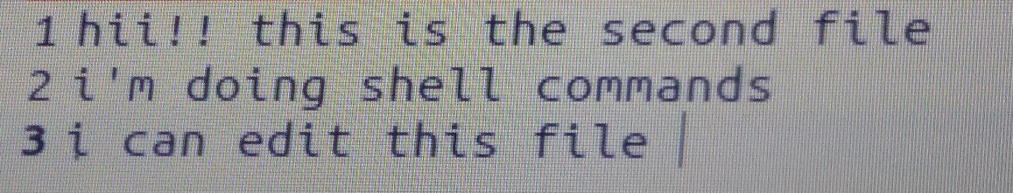

9. Display the contents of file **demo1** in terminal.

Gedit demo1

10. List the files and folders present in Dir3.cd dir2

Ls

11. Go to Dir 2.

Cd dir2

12. Go to your home directory. Ls -a

cd ~

13. Stay where you are, and list the contents of Dir3.

ls

14. List all the files (including hidden files) in your home directory.

Ls-l

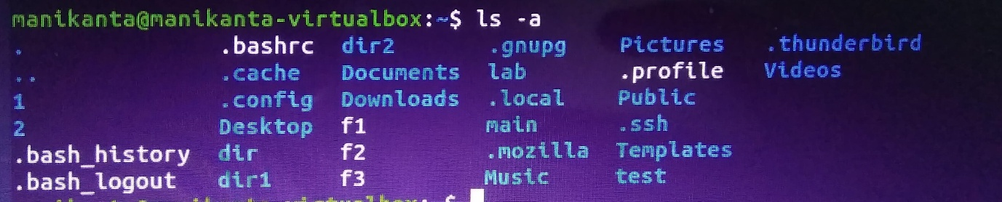

15. Create a new file **test1**, type and save the contents into your file.

Gedit test1 and I am working with linux shell.  Good bye

cp

16. Copy the contents of **test1** to **test2** in the same directory.

 Cp -r test1 test2

17. Rename **test2** as **test3**.

Mv test2 test3



18. Determine the file type of test1



19. Move the file **test3** to the directory Dir3.

 Cp test3 dir3

20. Create a file **count**, with content one to twenty in words with one line having only one number using a single command.

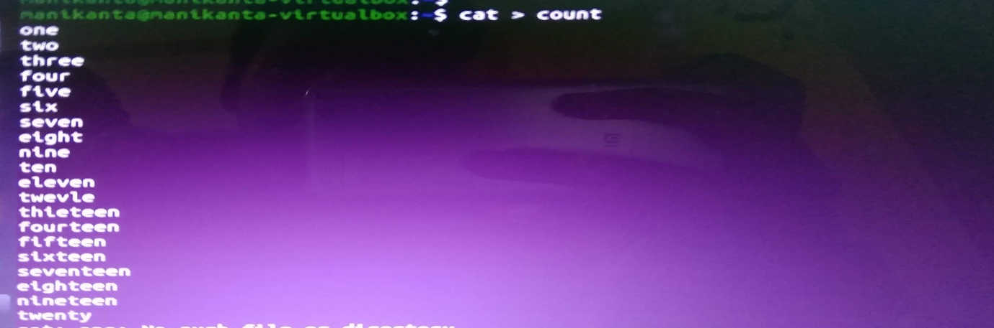Cat > count

21. Copy the file **count** to **count2** using cat command.

Cat count > count2

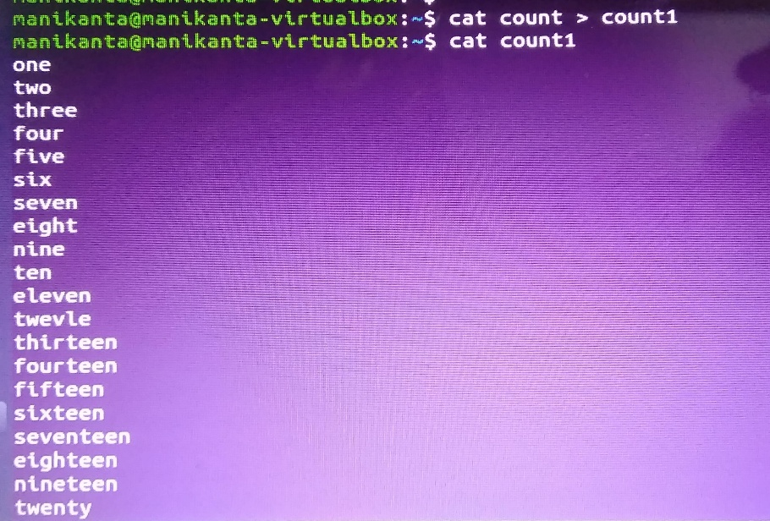

22. Create another file **count3** with numbers twenty one to twenty five (in five lines).

Cat > count3

One

Twoca

Three

Four

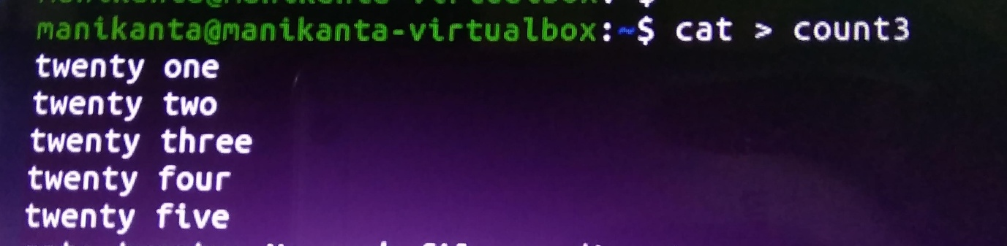Five

23. Concatenate the contents of files **count2** and **count3** and write it into the file **countfinal**.

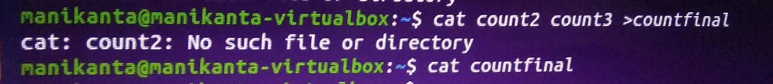Cd

24. Remove the files **demo1** and **demo2** in directory Dir3.

Rm demo1 demo2



25.Go to Dir2 and remove the subdirectory Dir3.

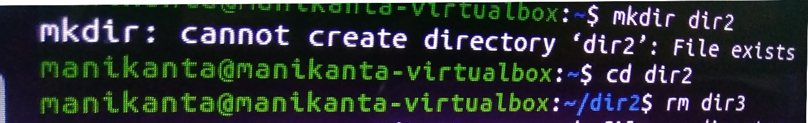 Cd dir2cdta

Rm dir3

26. Come back to your home folder and remove Dir2.

Cd ~

 Rm dir2

27. Display first 10 lines of the file **countfinal** in terminal.

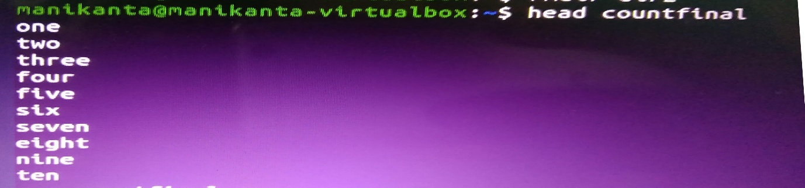

Head countfinal

28. Display last 10 lines of the file **countfinal** in terminal.

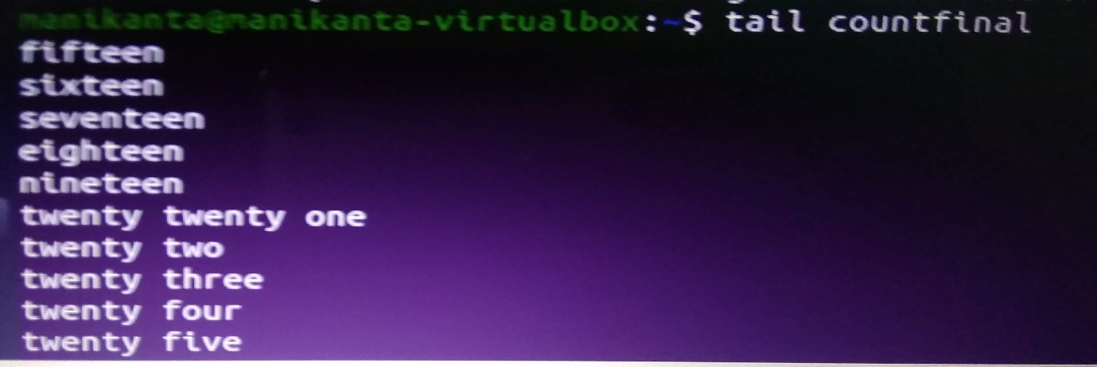 Tail countfinal

29. Display lines of the file **countfinal** in terminal.

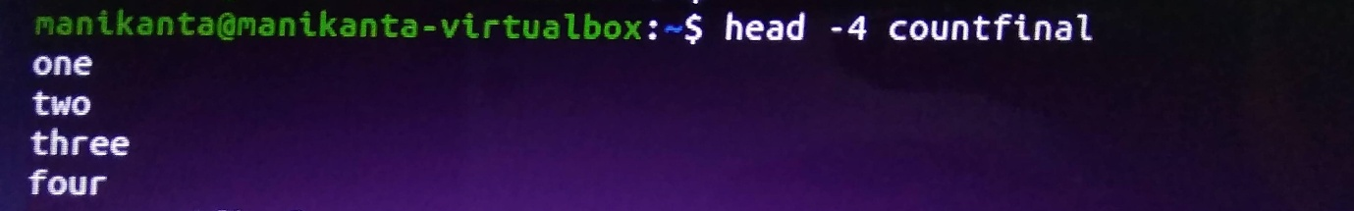

30. Display last 4 lines of the file **countfinal** in terminal.

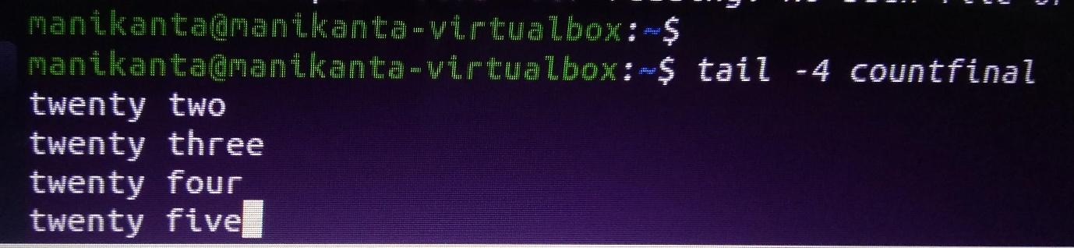

31. Display the contents of the file **countfinal** in the inverted form.(last line first and first line last)



